LabVIEW 2012, Panda3D-1.8.1

**Turn on VR**

Open VRE17.vi

Run cameraControl.py (VRE17.vi is needed for the communication between python and LabVIEW)

**Display VR by projectors**

Turning on the power of the resonant scanner

Run pmtProjectorGating2.vi

Note: 1. this code uses the line clock from the resonant scanner (8 kHz, through ScanImageB) to trigger the gating of PMT circuit and projector LEDs. The code controls the delay, duration and duty cycle of the gating signal. The online retriggering function is performed by a multifunction I/O device (PCIe-6321, National Instrument). 2. When the resonant scanner is not running (ex. not acquiring two-photon images), the multifunction I/O device will generate an 8 kHz TTL signal to trigger the projection of the VR (otherwise the fish will be in the dark in between two-photon imaging sessions).

**Perform experiment**

Run VRE17.vi

1. Align fish in the display of “Behavioral recording”. The 1st row of the image must include pixels representing the tail.

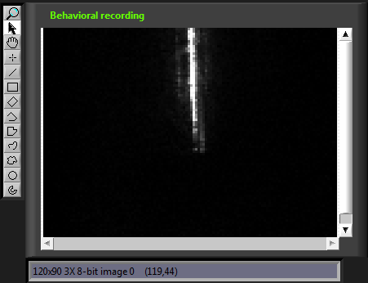

2. Click “Align Done”.

3. In the pop-up window, select a ROI for behavioral recording. The tail should not go beyond the ROI at any time during the experiment.

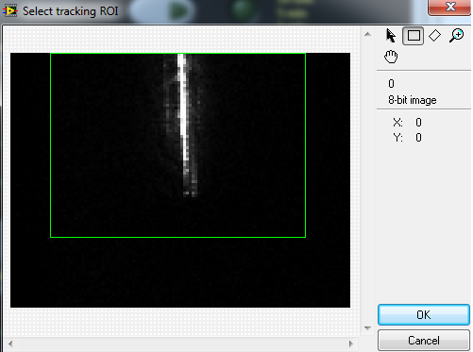

4. After 5 s, real-time tail tracking is displayed by 7 tracking points (red).

5. Click “Start experiment”.

6. In the pop-up window, click “OK”. A TTL signal is sent to ScanImageB to trigger two-photon imaging. Now behavioral recording and two-photon imaging is performed simultaneously.